PROJECT REPORT
CUSTOMER SUPPORT TICKET PRIORITY PREDICTION AND AUTOMATED ASSIGNMENT SYSTEM USING AGENTFORCE

1. Purpose of Empathy Analysis
Before designing any technical solution, it is important to understand the people who will use it. Empathy analysis helps the team see the support process through the eyes of each user: what they think, hear, see, say and do, what frustrates them, and what they hope to achieve. The findings of this report guided every design decision in the Customer Support Ticket Priority Prediction and Automated Assignment System.

2. User Personas
Persona | Role and goal | Main concern
Support Agent | Handles assigned tickets and wants to work on critical issues first | Urgent tickets are hidden among many normal tickets
Customer | Raises an issue and wants it resolved quickly | Critical issue may wait behind lower-priority tickets
Support Manager | Ensures team performance, correct assignment and SLA compliance | Manual assignment and unnoticed old tickets

3. Empathy Map Canvas
The empathy map below captures the shared view of the customer, the support agent and the manager. They have different roles but one shared goal: fast and correct resolution of every ticket.
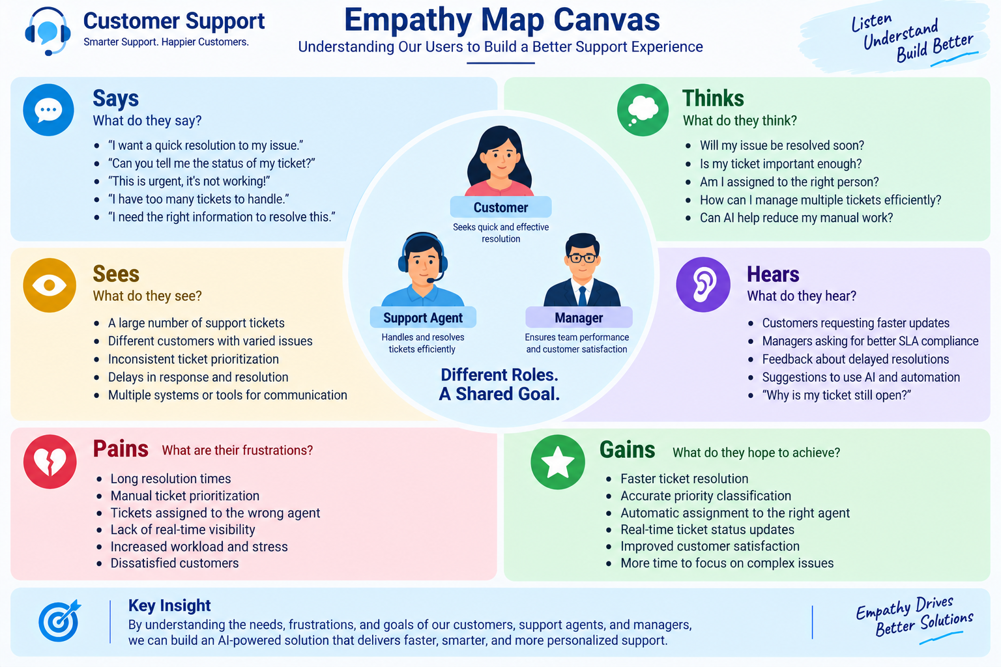
Figure 1: Empathy map canvas

3.1 Empathy Map: Support Agent (Primary Persona)
Dimension | Observation
Thinks and feels | Wants critical issues identified quickly so urgent customer problems receive attention
Hears | Customer issue descriptions and support requests
Sees | Ticket status, issue type, description, priority level, assignment and SLA risk
Says and does | Reviews tickets, handles assigned cases and focuses on urgent support issues
Pain | Manual prioritization, missed urgency signals and delays in handling critical tickets
Gain | Automatic priority classification, clearer assignment, urgent-task creation and less manual effort

3.2 Empathy Summary for Customer and Manager
Dimension | Customer | Support Manager
Says | "This is urgent, it is not working!"; "Can you tell me the status of my ticket?" | "I need the right ticket with the right person."
Thinks | Will my issue be resolved soon? Is my ticket important enough? | Is the ticket assigned to the right level? Can AI reduce manual work?
Hears | "Why is my ticket still open?" | Requests for better SLA compliance and faster resolution
Pains | Long waiting time, no updates, dissatisfaction | Overload, inconsistent prioritization, SLA risk
Gains | Faster resolution and timely updates | Accurate assignment, better visibility, productive team

4. Customer Problem Statements
Using the problem statement template, five problem statements were identified from the three personas.
No. | I am | I am trying to | But | Because | Which makes me feel
PS-1 | Support Agent | Focus on critical tickets first | Tickets are not always prioritized automatically | Prioritization can be manual | Frustrated
PS-2 | Customer | Get urgent issues resolved quickly | Critical issues may wait behind lower-priority tickets | Support teams handle large ticket volumes | Concerned
PS-3 | Support Manager | Assign tickets to the right support level | Assignment may need manual decisions | Urgency is not consistently analyzed | Overwhelmed
PS-4 | Support Agent | Identify urgent issues from descriptions | Important keywords can be missed | Descriptions contain different urgency signals | Uncertain
PS-5 | Support Manager | Reduce SLA-related risk | Older unresolved tickets may go unnoticed | SLA risk needs additional checking | Concerned

5. Customer Journey Map
The journey map follows a customer from raising a ticket to giving feedback. It shows what the customer does, which touchpoints are used, how the customer feels, and what the system does at each stage.
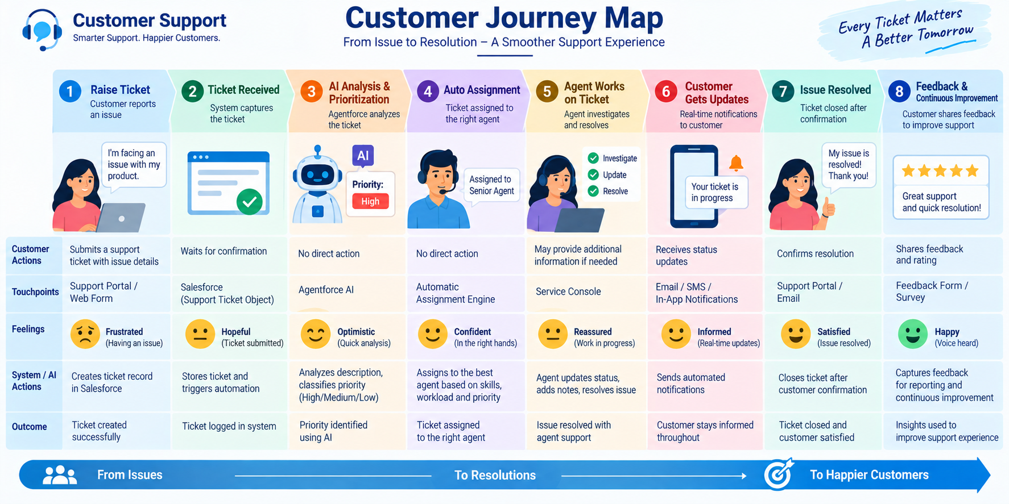
Figure 2: Customer journey map
Stages: Ticket Creation, Account Identification, Ticket Retrieval, Description Analysis, Priority Classification, Agent Assignment, Urgent Task Creation, Support Handling and Resolution.

6. Key Insights
- Customers feel frustrated when raising an issue and reassured only when they know someone is working on it. Fast priority detection builds this trust early.
- Support agents lose time on sorting. The system should do the sorting for them and give a clear priority and assignment.
- Managers need consistency. Rule-based logic gives the same result for the same type of ticket every time.
- Old tickets can silently become SLA risks, so an SLA risk check is valuable.

7. Design Implications
Insight | Design decision
Agents waste time sorting tickets | Flow decision analyzes the description and sets High, Medium or Low
Critical tickets need immediate action | Task "Urgent Ticket Handling" is created automatically for High priority
Managers want correct assignment | High-priority tickets are assigned to a Senior Support Agent
Users prefer simple interaction | Agentforce asks only for the Account Name and replies in plain language
SLA risk can be overlooked | Optional SLA decision flags tickets older than 2 days

8. Conclusion
By understanding the needs, frustrations and goals of customers, support agents and managers, the team defined a clear problem and a user-focused solution: an AI-assisted system that delivers faster, smarter and more consistent support.

